

A

Project Report On

Astrome Mould Plast

Submitted in the Partial fulfilment of the requirement for awarding the degree of

Bachelor of Computer Application (BCA)

SEM V Year 2022

By

**Gorasiya Dhruv**

**Under the Guidance of**

**Prof: Rajdeepsir**



**DEPARTMENT OF BCA**

SHASHTRI SWAMI SHRI DHARJIVANDISAJI INSTITUTE OF INFORMATION TECHNOLOGY Junagadh

**Acknowledgment**

I am very thankful to all, who have helped me in preparing this project. I am very much happy to present this Project Report Before you, expecting that you will acknowledgement it. It is a master of great pleasure for that we have a unique opportunity of the project works and now we have an opportunity to express our view on the same.

As a part of our academic study, as the student of 5th semester of B.C.A. I required to undergone training for software project for an institute or industry in order to obtain practical knowledge and our view regarding the same.

I am heartily thankful to assistant director Mr.Bharad Sir, Principle MR.Dhaval trivedi of S.S.S.D.I.I.T. collage to give me opportunity in BCA Program, and Mr.Milind Sir Head of the department for their end-less and great support.

I would like to express our special thanks to Principal and H.O.D of the “SSSDIIT” to have given their precious time for us and provide all the possible information for our practical study.

Yours Faithfully,

Gorasiya Dhruv

**Abstract**

As a part of my course curriculum of BCA in grand project report, I am assigned some practical studies as well as the theoretical knowledge in the related areas for completing the project of real time applications. I has been preparing Grand project report Desktop Application - “Astrome Mould Plast”.

Student of BCA learn different concepts in their curriculum. This provides them with the theoretical and practical knowledge of Information Technology. The purpose of commencement of project is to make student aware of how to implement the theoretical and practical knowledge in real time applications.

This project really enhances My knowledge about Applications and the Information Technology industry as a whole, and I believe this will help me in near future.

**Preface**

First of all, I would to say that this project report of **Astrome Mould Plast** presents against you for project as a subject in 6th semester in BCA

Without a website, people may question your legitimacy as a business. Having a website is an opportunity to make a great first impression and give people comfort that you're a real business. Showcasing your brand to your prospective customers is one of the most important things that you can do.

A website is more than just throwing some words up on a page and calling it good, it’s an important part of your branding and marketing strategy. It needs to be well-designed and user-friendly, with clear calls to action. It needs to be updated regularly with fresh content. And it needs to be optimized for search engines so potential customers can actually find it. In other words, it’s a lot of work. But the good news is, there are people who can do all that for you. So if you don’t have a website, what are you waiting for? Get one! Your customers will thank you for it..

**Index**

|  |  |  |
| --- | --- | --- |
| **No** | **Description** | **Page No.** |
| 1 | Introduction and objectives of project | 7 |
| 2 | Requirement analysis | 8 |
| 3 | Tools and Environment used | 12 |
| 4. | Analysis and design of project | 17 |
| 5. | Program structure | 22 |
|  | (5.1) User interface and black box testing |  |
|  | (5.2) Designing database |  |
| 6 | Screen shots and source code of project | 27 |
| 7 | Limitation of project | 42 |
| 8 | Future application of the project | 42 |
| 9 | Bibliography | 43 |

**Project Profile**

|  |  |
| --- | --- |
| **Project Title** | Astrome Mould Plast |
| **Developed By** | Gorasiya Dhruv |
| **Class** | BCA Sem 6th-(B) |
| **Year** | 2022-23 |
| **Front End** | React js , Node js |
| **Back End** | MongoDB |
| **Guided By** | Prof. Rajdeepsir |
| **Project Submitted To** | S.S.S.D.I.I.T College Junagadh |

**1. Introduction and Objective of the Project:**

**INTRODUCTION**

Water tanks are used to provide storage of water for use in many applications, drinking water, irrigation agriculture, fire suppression, agricultural farming, both for plants and livestock, chemical manufacturing, food preparation as well as many other uses. Water tank parameters include the general design of the tank, and choice of construction materials, linings.

Various materials are used for making a water tank: plastics (polyethylene, polypropylene), fiberglass, concrete, stone, steel (welded or bolted,[citation needed] carbon, or stainless). Earthen pots, such as matki used in South Asia, can also be used for water storage. Water tanks are an efficient way to help developing countries to store clean water.

**OBJECTIVE OF THE PROJECT**

* Water tanks are used to store water for various purposes such as household water supply, irrigation, and fire suppression. They come in different sizes, shapes, and materials like plastic, fiberglass, concrete, and steel.
* The primary objective of water tanks is to store water for future use, especially in areas where there is a shortage of water or an unreliable water supply.
* They also help in maintaining water pressure in the plumbing system and reduce water bills by storing rainwater or graywater for non-potable uses.

**2. Requirement Analysis**

**THE PRESENT SYSTEM**

Water tanks are used in various applications in the present system, including:

* Residential and commercial buildings for storing water for domestic use, firefighting, and irrigation.
* Agriculture for storing water for crop irrigation.
* Industrial processes where water is needed for manufacturing or cooling processes.
* Municipal water systems for storing treated water before distribution.
* Emergency response situations where water is needed for firefighting, disaster relief, or other emergencies.

**IDENTIFICATION OF NEED**

Water tanks are storage containers of water; these tanks usually stores water for human consumption. The need for water tanks is as old as civilized man. Water tanks provide the storage of drinking water potable, irrigation,agriculture, fire suppression, agricultural farming and live stoke, chemical manufacturing, food preparation and many other applications.

Various materials are used for constructing water tanks; plastic, polyethylene, polypropylene, fiberglass, and concrete, steel (welded or bolted, carbon or stainless)

**PRELIMINARY INVESTIGATION**

The preliminary investigation was carried out to determine the feasibility of the system.

The existing documents were reviewed, and minutely analysed. They are including

* Register (In which all records are being kept).
* Details of Tanks types of services provided and their specifications are reviewed.

The method of keeping records and its functionality are reviewed and changes were suggested for improvement. The management gladly express apprehension about the changes.

**CONDUCTING INTERVIEWS**

Several interviews were conducted at various levels. The two prime interviewees were the management personnel and the computer operators. It made further clear the working of the system and the changes desired by them. Several suggestions were also made, some of which were accepted by the management.

**FEASIBILITY STUDY**

* TECHNICAL FEASIBILITY

The current system has Personal Computers. All the works are done on Word Processor and spreadsheets. The company already possesses the required software.

In the current working system, it requires time to produce the reports. The response time is high for processing queries.

The Proposed System:

In the proposed system, there will be a standalone Personal Computer with the required application. And with minor modification in software it can also run in network. There is no significant difference between the current system and the proposed design of the system. The System will generate reports. The system will also have feature to generate penalty invoices.

* ECONOMICAL FEASIBILITY

They can help to reduce water bills by collecting rainwater, which can be used for irrigation, toilet flushing, and other non-potable uses.

Moreover, water tanks can also contribute to the sustainability of the environment by reducing the demand for mains water and decreasing the pressure on the water supply infrastructure. This, in turn, can help to lower the cost of maintaining and expanding the water supply system.

The initial cost of purchasing and installing a water tank can vary depending on the size, type, and location. However, the long-term cost savings can outweigh the upfront investment, especially in areas with high water costs or water scarcity.

* OPERATIONAL FEASIBILITY

The system is expected to work smoothly when developed and installed. There has been participation of management and the computer operators in planning and development of the system. There will be a slight change in the format of the reports to which management agreed. There is no disturbance in organizational structure of the astrome mould plast. The new application for the system will have Graphical User Interfaces (GUI). The applications with GUI are very easy to handle and operate. There is no needs to any kind of learning this software because it is easy to learn or the software is user friendly. They need to be instructed regarding using of the application software.

**3. Tools / Environment Used:**

**SOFTWARE USED TO DEVELOP THE SYSTEM**

**Platform**

* Visual studio code

**RDBMS**

* MongoDB

**HARDWARE USED TO DEVELOP THE SYSTEM**

● Processor Intel ® Core™ i5-1120U CPU

● RAM 8 GB

● Monitor DELL

● SSD 512 gb

● Keyboard Dell keyboard

● Mouse Trackpade

**REQUIREMENT TO RUN THE DEVELOPED SOFTWARE**

**Software Requirements:**

* Windows 10 Operating System
* Node js
* MongoDB

**System Requirements:**

**Minimum:** intel i3 ( 4 RAM)

**Recommended:** intel i5 (8 RAM)

**Disk Space:** 1 gb

**Display Properties:**

**Minimum:** 1920 x 1080

**Recommended:** 1920 x 1080

**IMPLEMENTATION**

The System would be capable of running on very low-end machines with just a minimum setup of a MongoDB Server. The implementation phase of the project would include:

* Total installation of application software and server setup
* This is personal use computer software so there is no support of any centralized system or networked multi-layered system.

\ **I developed the Project System in the given environment due to following reasons:**

**SOFTWARE TOOLS USED**

**1.Visual studio code Editor:**

Visual Studio Code is a source-code editor that can be used with a variety of programming languages, including [Java](https://en.wikipedia.org/wiki/Java_(programming_language)), [JavaScript](https://en.wikipedia.org/wiki/JavaScript), [Go](https://en.wikipedia.org/wiki/Go_(programming_language)), [Node.js](https://en.wikipedia.org/wiki/Node.js), [Python](https://en.wikipedia.org/wiki/Python_(programming_language)), [C++](https://en.wikipedia.org/wiki/C%2B%2B), [C](https://en.wikipedia.org/wiki/C_(programming_language)), [Rust](https://en.wikipedia.org/wiki/Rust_(programming_language)) and [Fortran](https://en.wikipedia.org/wiki/Fortran).[[16]](https://en.wikipedia.org/wiki/Visual_Studio_Code#cite_note-16)[[17]](https://en.wikipedia.org/wiki/Visual_Studio_Code#cite_note-17)[[18]](https://en.wikipedia.org/wiki/Visual_Studio_Code#cite_note-18)[[19]](https://en.wikipedia.org/wiki/Visual_Studio_Code#cite_note-19) It is based on the [Electron](https://en.wikipedia.org/wiki/Electron_(software_framework)) framework,[[20]](https://en.wikipedia.org/wiki/Visual_Studio_Code#cite_note-ars-electron-20) which is used to develop [Node.js](https://en.wikipedia.org/wiki/Node.js) [Web applications](https://en.wikipedia.org/wiki/Web_application) that run on the [Blink layout engine](https://en.wikipedia.org/wiki/Blink_layout_engine). Visual Studio Code employs the same editor component (codenamed "Monaco") used in [Azure DevOps](https://en.wikipedia.org/wiki/Azure_DevOps_Server) (formerly called Visual Studio Online and Visual Studio Team Services).

* + Instead of a project system, it allows users to open one or more directories, which can then be saved in workspaces for future reuse. This allows it to operate as a [language-agnostic](https://en.wikipedia.org/wiki/Language-agnostic) code editor for any language. It supports many programming languages and a set of features that differs per language. Unwanted files and folders can be excluded from the project tree via the settings. Many Visual Studio Code features are not exposed through menus or the user interface but can be accessed via the command palette.
  + Coding speed increased
  + Increased accuracy
  + Work more in less time

It is open source platform the there is no addition cost to pay to use this software. With better UI development any expert or any beginner can use.it support various type of coding mode and convenient environment for working with framework.

**2.Introducing MongoDB**

MongoDB, the most popular NoSQL database, is an open-source document-oriented database. The term ‘NoSQL’ means ‘non-relational’. It means that MongoDB isn’t based on the table-like relational database structure but provides an altogether different mechanism for storage and retrieval of data. This format of storage is called BSON ( similar to JSON format).

Features of MongoDB:

1. Document Oriented: MongoDB stores the main subject in the minimal number of documents and not by breaking it up into multiple relational structures like RDBMS. For example, it stores all the information of a computer in a single document called Computer and not in distinct relational structures like CPU, RAM, Hard disk, etc.

2. Indexing: Without indexing, a database would have to scan every document of a collection to select those that match the query which would be inefficient. So, for efficient searching Indexing is a must and MongoDB uses it to process huge volumes of data in very less time.

3. Scalability: MongoDB scales horizontally using sharding (partitioning data across various servers). Data is partitioned into data chunks using the shard key, and these data chunks are evenly distributed across shards that reside across many physical servers. Also, new machines can be added to a running database.

4. Replication and High Availability: MongoDB increases the data availability with multiple copies of data on different servers. By providing redundancy, it protects the database from hardware failures. If one server goes down, the data can be retrieved easily from other active servers which also had the data stored on them.

5. Aggregation: Aggregation operations process data records and return the computed results. It is similar to the GROUPBY clause in SQL. A few aggregation expressions are sum, avg, min, max, etc

Where do we use MongoDB?

➢ Big Data: If you have huge amount of data to be stored in tables, think of MongoDB before RDBMS databases. MongoDB has built-in solution for partitioning and sharding your database.

➢ Unstable Schema: Adding a new column in RDBMS is hard whereas MongoDB is schema-less. Adding a new field does not effect old documents and will be very easy.

➢ Distributed data Since multiple copies of data are stored across different servers, recovery of data is instant and safe even if there is a hardware failure.

Getting Started

This tutorial walks you through inserting test data into a MongoDB database and querying that data using the documentation's embedded web shell. You do not need to deploy or install MongoDB to complete this tutorial.

The examples in this tutorial use a subset of the Sample Mflix Dataset, which is part of the sample data included in MongoDB's cloud-hosted service, MongoDB Atlas. Atlas requires no installation overhead and offers a free tier to get started.

**AN OVERVIEW OF TECHNOLOGY**

**Relational Model:**

A relational model consists of a collection of tables each of which is assigned a unique name. a row in table represents a relationship among a set of values. Since a table is a collection of such relationship there is close correspondence between the concept of the table and the mathematical concept of relation, from which the relational data model takes its name. The relational model was propounded by E. F. Codd of the IBM and has since been acknowledged as a very important concept in DBMS. The relational model has established itself as primary data model for commercial data processing application.

**Domain:**

A domain is a pool of values from which the actual values appearing in a given column are drawn. A domain is said by atomic if element of the domain is considered to be invisible units. For each attribute, there is a set of permitted values called the domain of that attribute. For all relation r, the domain of all attributes of be atomic. A domain is atomic if elements of the domain are considered to be invisible units.

**Entity:**

An entity is an object that exists and is distinguishable from other objects.

An entity set is a set of entities of the same type. An entity is represented by a set of attributes.

**Attributes:**

An attribute is a function, which maps from an entity set into a domain. For each attribute there is a set of permitted values, called the domain of that attribute.

**Keys:**

It is important to be able to specify how entities and relationships are distinguishable. The keys are used to make difference among the different entities.

Super key:

A super key is asset of one or more attributes which; taken collectively, allow us to identify uniquely an entity in the entity set. For e.g.- The entry number attribute of the entity set course detail is sufficient to distinguish one course entity from other. Thus, course no is a super key.

Candidate key:

A super key may contain extraneous attributes. If K is a super key, then so is any superset o K. we are often interested in super keys for which no proper subset is a super key. Such a minimal super keys are called candidate key.

Primary key:

A primary is a set of one or more attributes that can uniquely identified tuples with in the relational. It denotes a candidate key that is chosen by the database designer as the primary means of identifying entities with an entity set.

**Relational algebra:**

The relational algebra is a collection of operations on relations. Each operation takes places one or more relations as its operands and procedure another relation as its result. It consists of a set of operations that take one or two fundamental operational operations in the relational algebra are select, project, Cartesian product, rename union and set difference.

**Relational Commercial Language:**

SQL (Structured Query Language):

SQL is a language that enables you to create and operate on relational database, which are set of related information stored in tables. SQL uses the combination of relational algebra and relational calculus constructs. The original version was developed at IBM’s San Jose Research Laboratory. This language originally called sequel, was implemented as part of the system project in early 1970s.

**4.Analysis & Design of the Project**

**PROJECT MODULES ANALYSIS WITH DFDs**

* A data flow diagram (DFD) is graphical representation of the “flow” of data through an information system.
* A DFD shows what kinds of information will be input to and output from the system.
* One of the most widely used system analysis process models is the data flow diagrams.

ZERO LEVEL Diagram:

Admin

User

Astrome

FIRST LEVEL Diagram:

Login

Types_of_product

Types_of_product

Astrome

Product

Product

Contact

Gallery

Contact

Gallery

SECOND LEVEL Diagram:

A_contact

Images

Product

Type_of_pro

User_Admin

Admin

View

Delete

View

Edit

Add

View

Delete

Delete

Edit

Add

View

Edit

Add

User

A_contact

Images

Product

Type_of_pro

Add contact

View

View

View

View

**WATERFALL MODULE:**

Requirement Analysis

System Design

Implimention

Testing

Deployment

Maintenance

**5.Programme Structure:**

(5.1) user interface & black box testing:

**User Interface:**

The user interface is perhaps the most important part of an application; it's certainly the most visible. To users, the interface is the application; they probably aren't aware of the code that is executing behind the scenes. No matter how much time and effort you put into writing and optimizing your code, the usability of your application depends on the interface.

The user ultimately determines the usability of any application. Interface design is an iterative process; rarely is the first pass at designing an interface for your application going to yield a perfect interface. By getting users involved early in the design process, I have created a better, more usable interface with less effort. Perhaps the most important principle of interface design is one of simplicity.

The best place to start when designing a user interface is to look at some of the best-selling applications from Microsoft or other companies; after all, they probably didn't get to be best sellers because of poor interfaces. One of the main advantages of the Windows operating system is that it presents a common interface across all applications. A user that knows how to use one *Windows-based application* should be able to easily learn any other. Unfortunately, applications that stray too far from the established interface guidelines aren't as easily learned.

In this application user will find attractive theme which is implement using react js. All user interface elements are written in pure react js. Such as buttons, menu-bar, product type card and all product details, fonts, things are made up with the react js. It is simple screen size application. React js make easy to make this application.

I don't need to be an artist to create a great user interface — most of the principles of user interface design are the same as the basic design principles taught in any elementary art class. The elementary design principles of

composition, colour, and so forth apply equally well to a computer screen as they do to a sheet of paper or a canvas.

**Black Box Testing:**

A black-box test examines some fundamental aspect of a system with little regard for the internal logical structure of the software.

When computer software is considered, black-box testing alludes to tests that are conducted at the software interface. Although they are designed to uncover errors, black-box tests are used to demonstrate that software functions are operational, that input is properly accepted and output is correctly produced, and that the integrity of external information (e.g., a database) is maintained.

Black-box testing, also called Behaviour testing, focuses on the functional requirements of the software. That is, Black-box testing enables the software engineer to derive sets of input conditions that will fully exercise all functional requirements for a program.

In my system Black-box testing attempts to find errors in the following categories

1. Incorrect or missing functions.
2. Interface error
3. Error in data structures or external data base access.
4. Behaviour or performance error
5. Initialization and termination errors.

Basically, in my system, Black-box tests are designed to make my system an error free system. I used validity test in each form.

* **Functional Validity Testing**

My project system is well functional. Each and every step has tested during design phase of software development.

* **System Behaviour and Performance Testing**

My system performs well by using low computer resources. For this purpose, I used very large numbers of records for testing.

* **Specific Combination of data Have on System Operation**

In my system, I used two specific combinations of data. Two different typed of data are used in application.

(5.2) Designing database:

There are following are given structure of database tables.

**Admin Login Database Table**

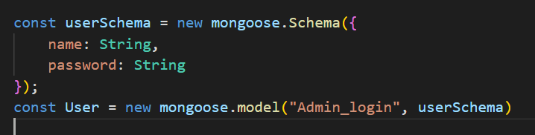

**Admin type_of_product Database table**

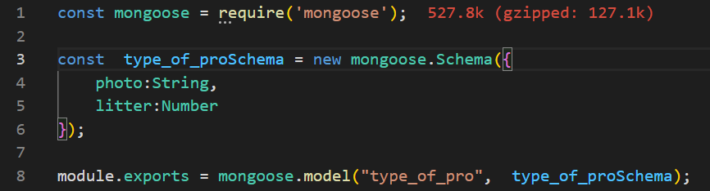

**User Product Database Table**

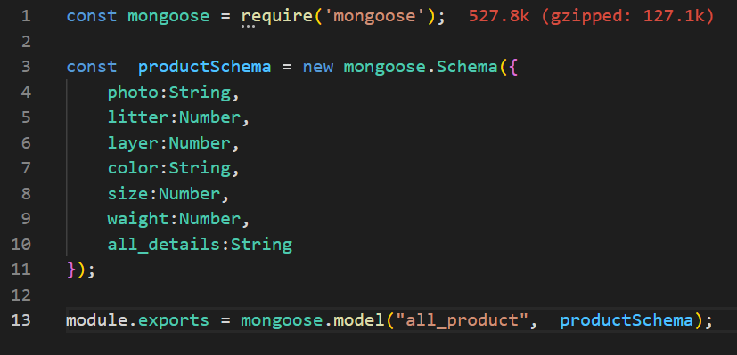

**User Image Database Table**

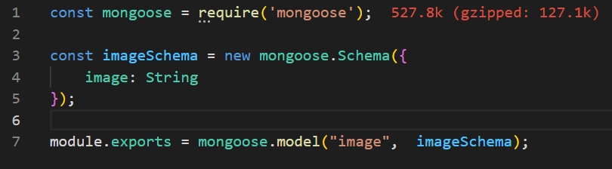

**User Contact Database Table**

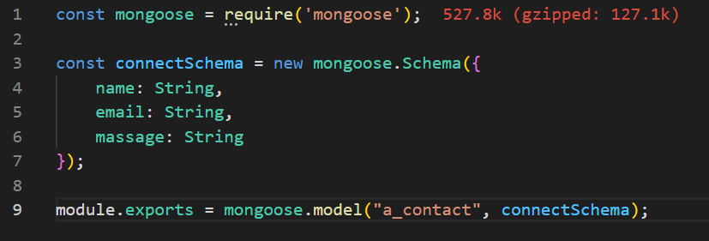

**6.Screen Shots And Source Code Of Project:**

**Figure 1:**

**Admin panel login page**

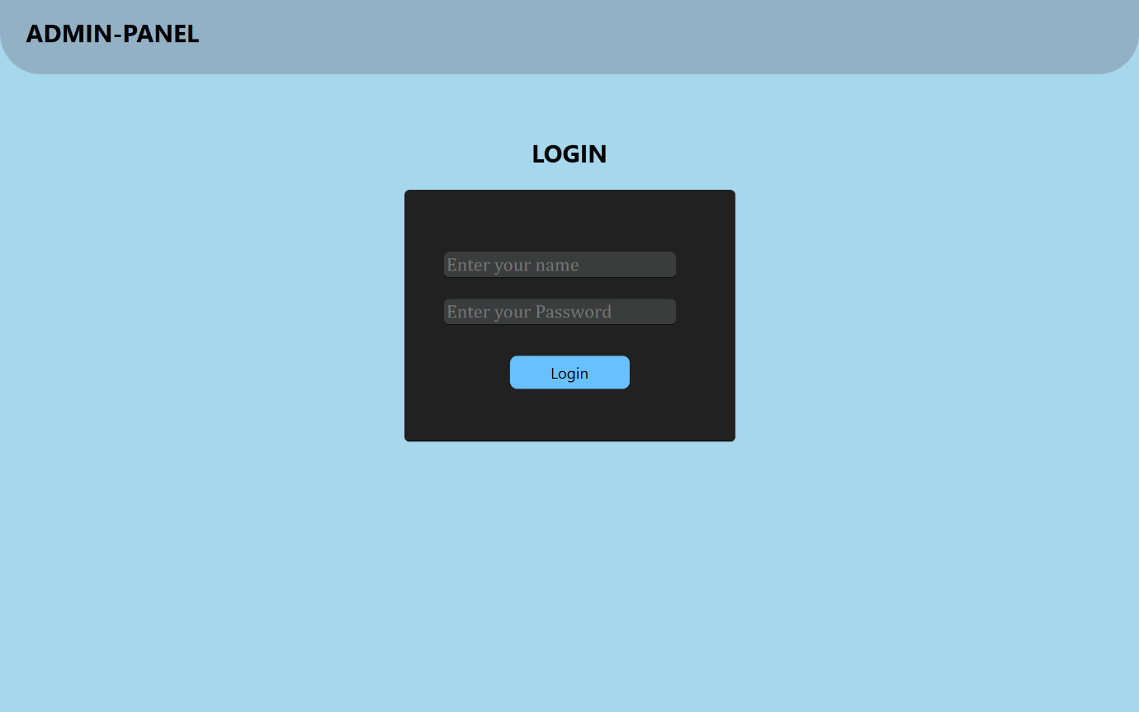

**Figure 2:**

**Add type_of_product**

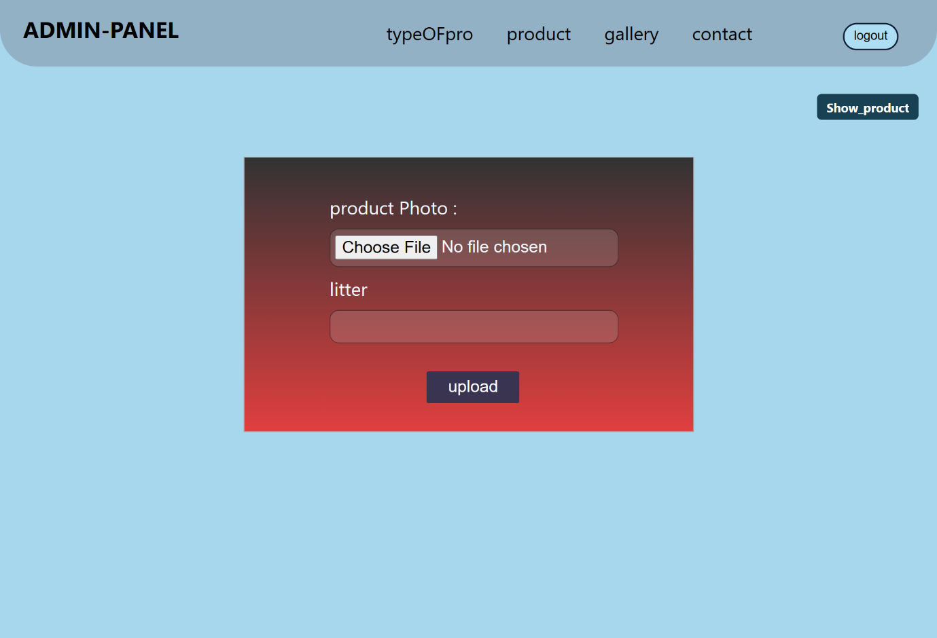

**Display type_of_product**

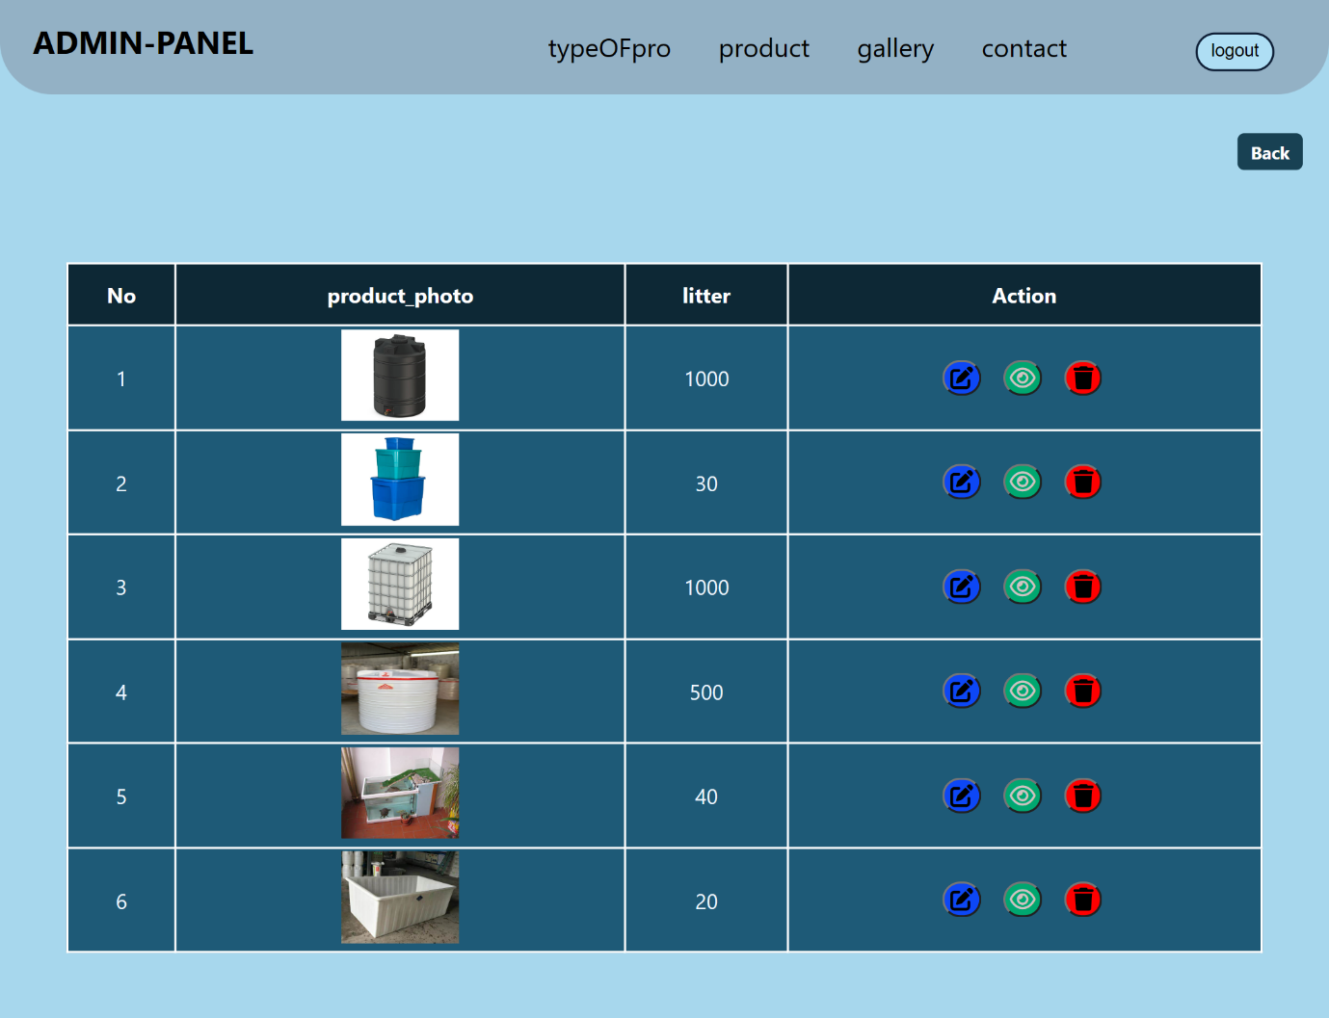

**View type_of_product**

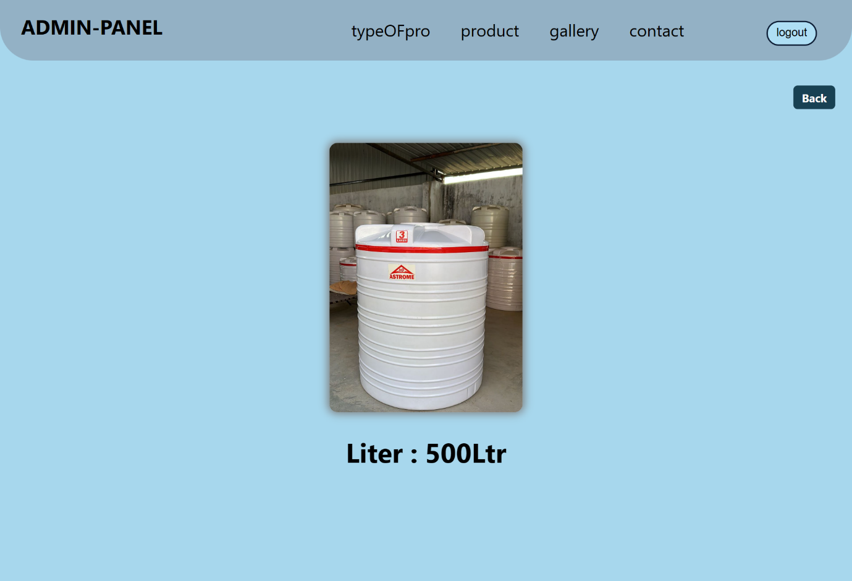

**Figure 3:**

**Add product**

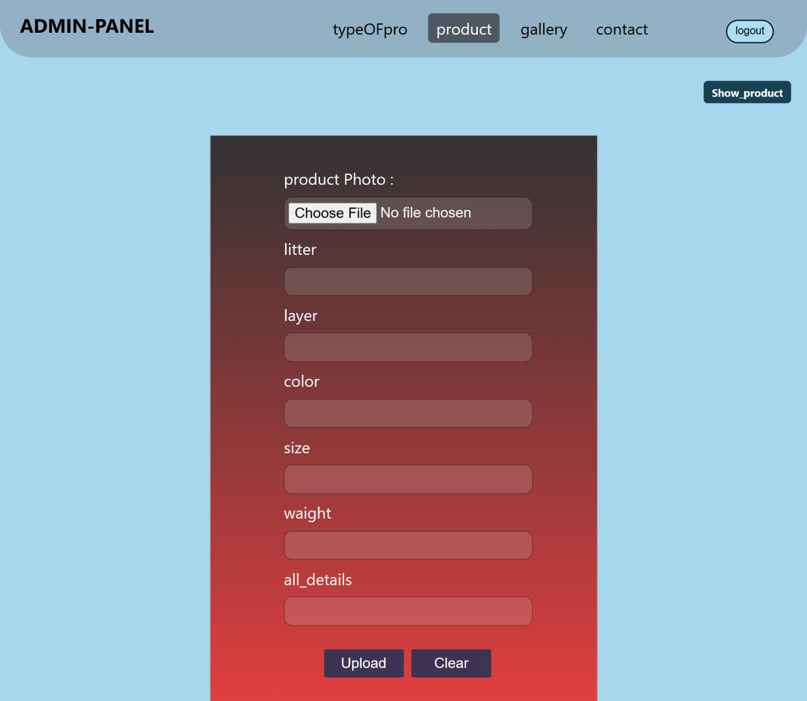

**Display product**

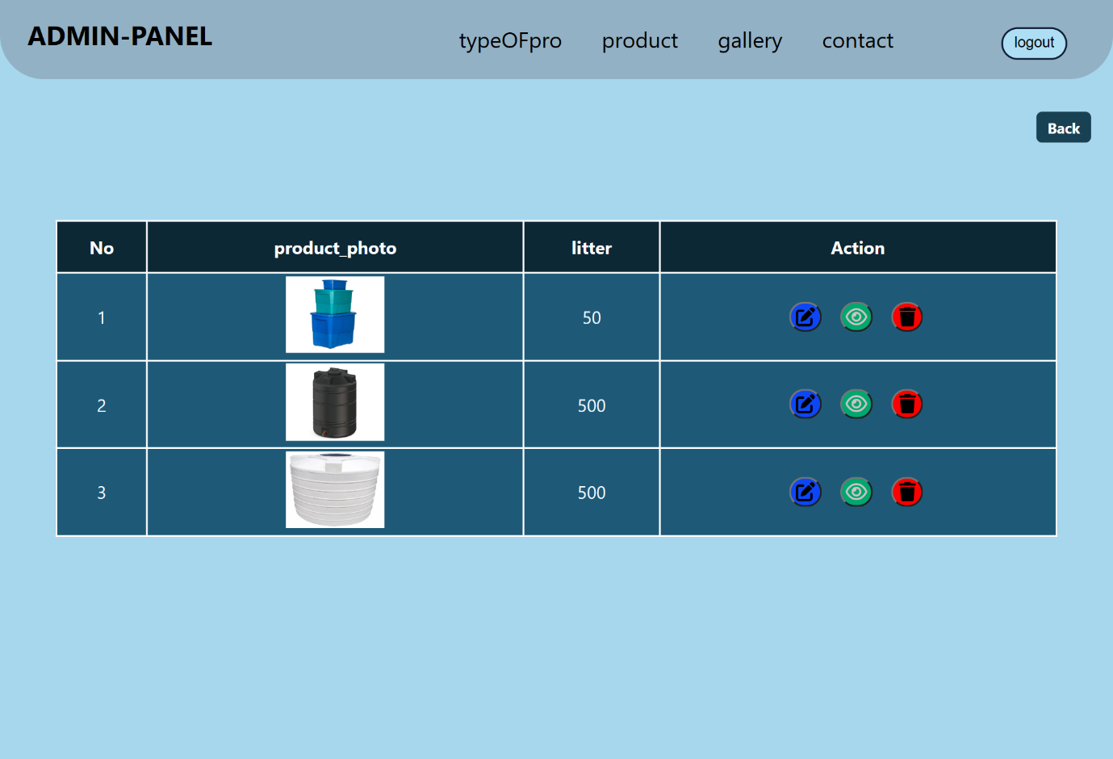

**View product**

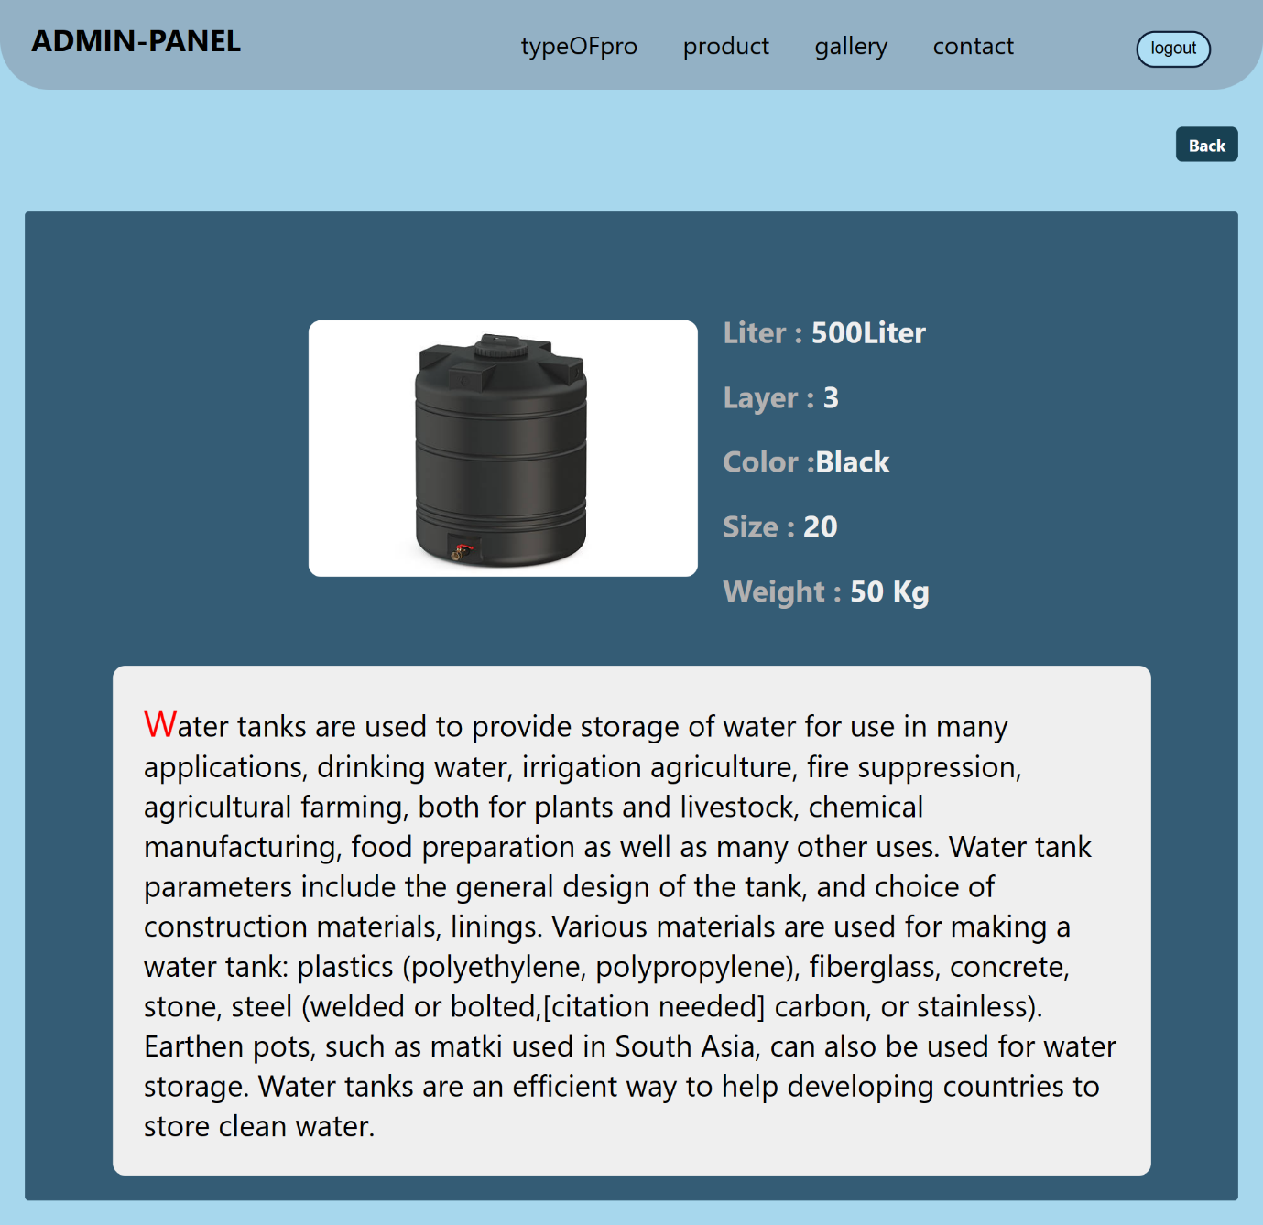

**Figure 4:**

**Add image**

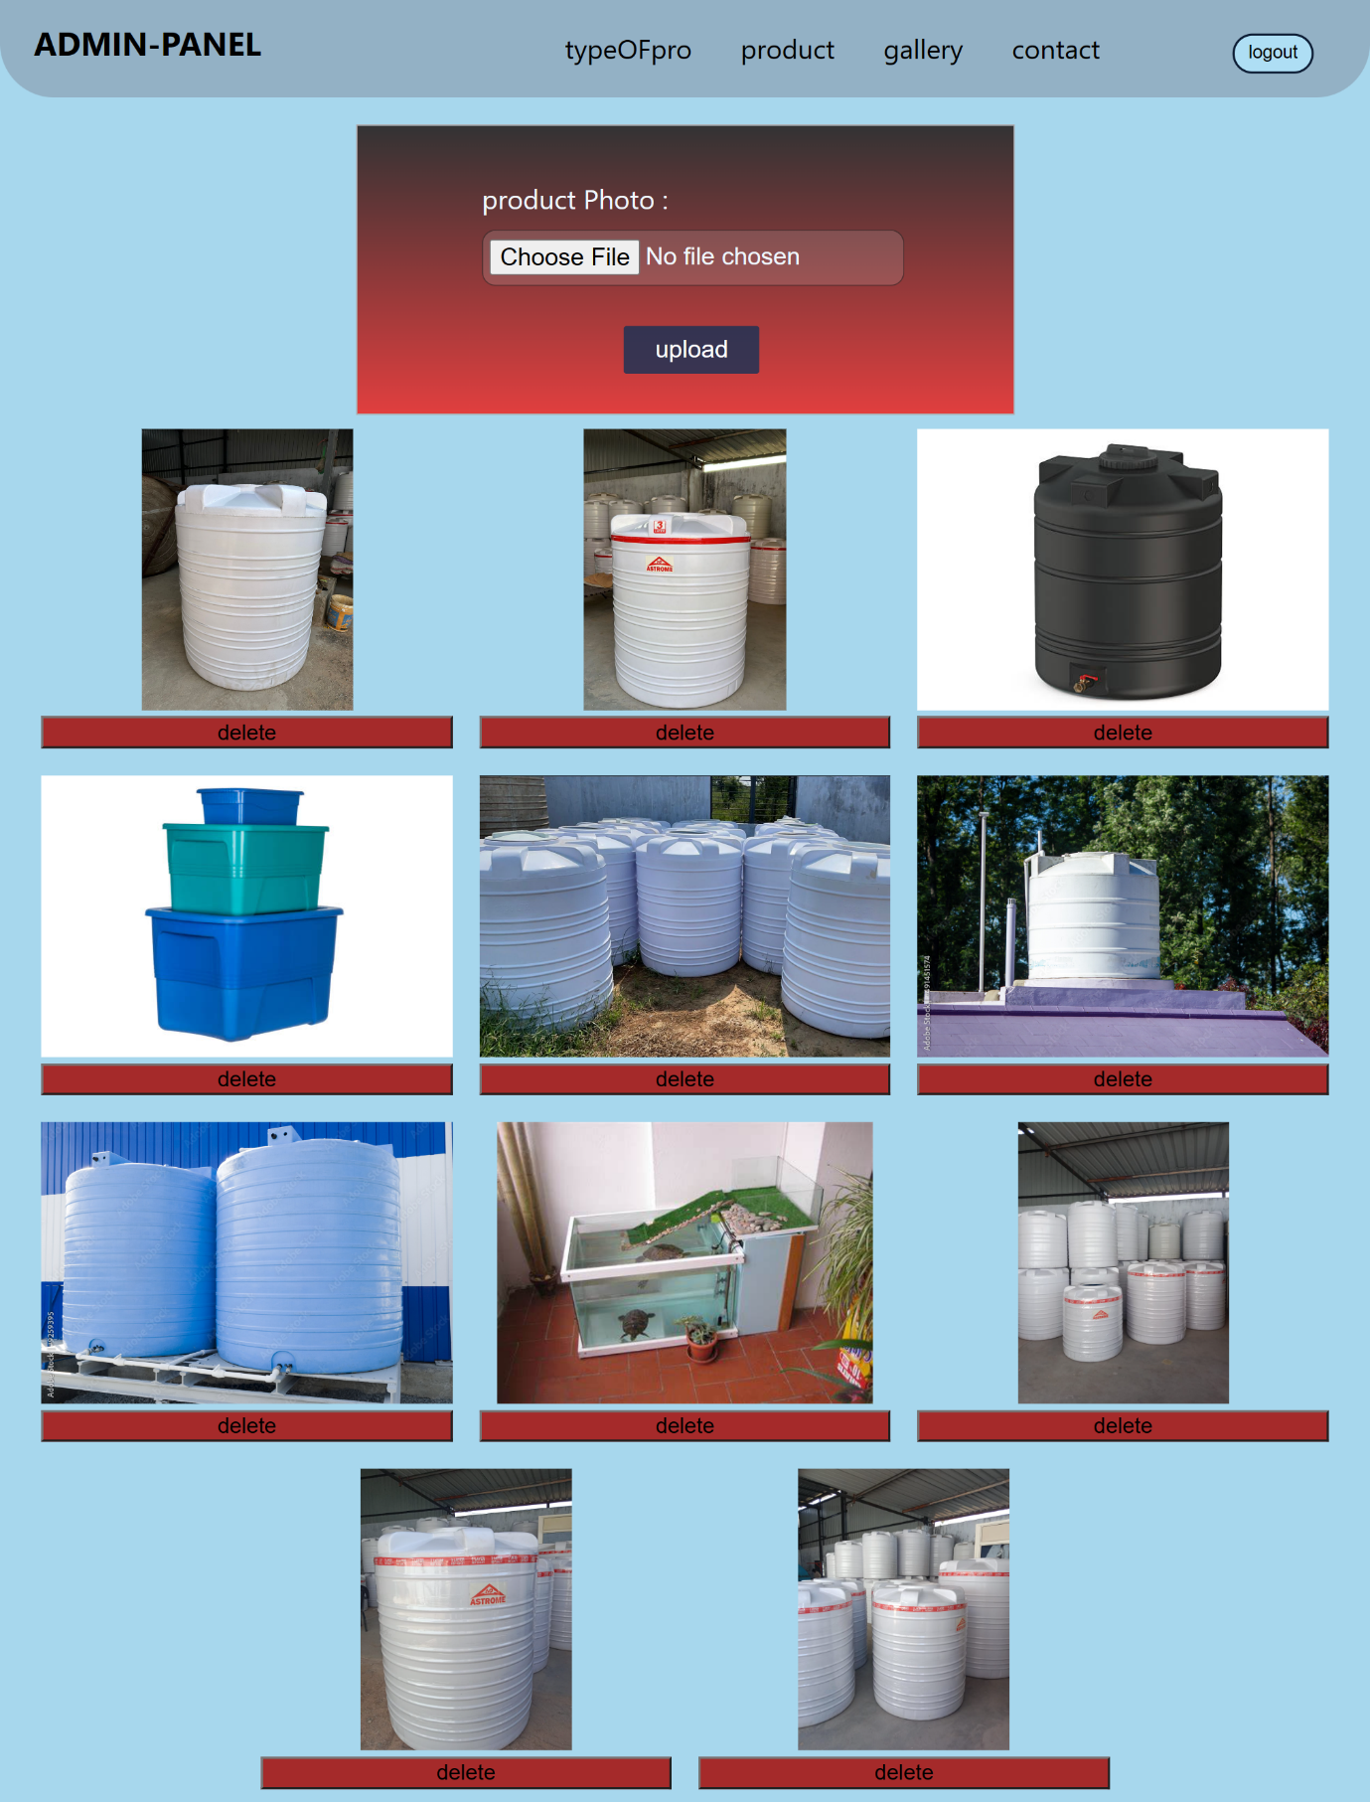

**Figure 5:**

**Show contact**

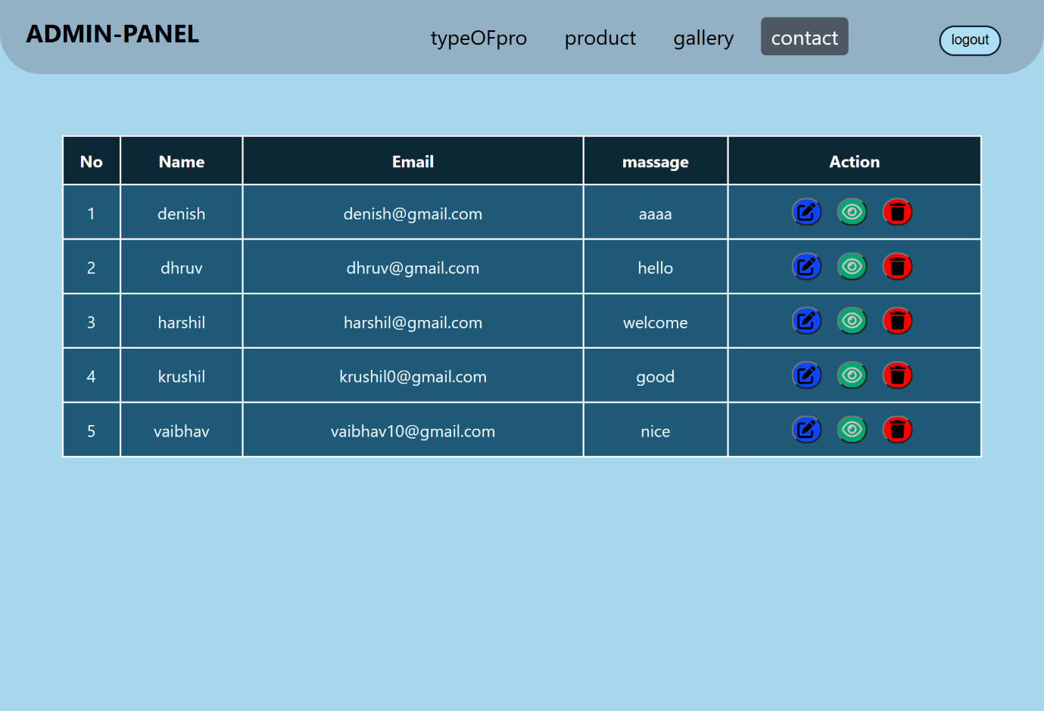

**Figure 6:**

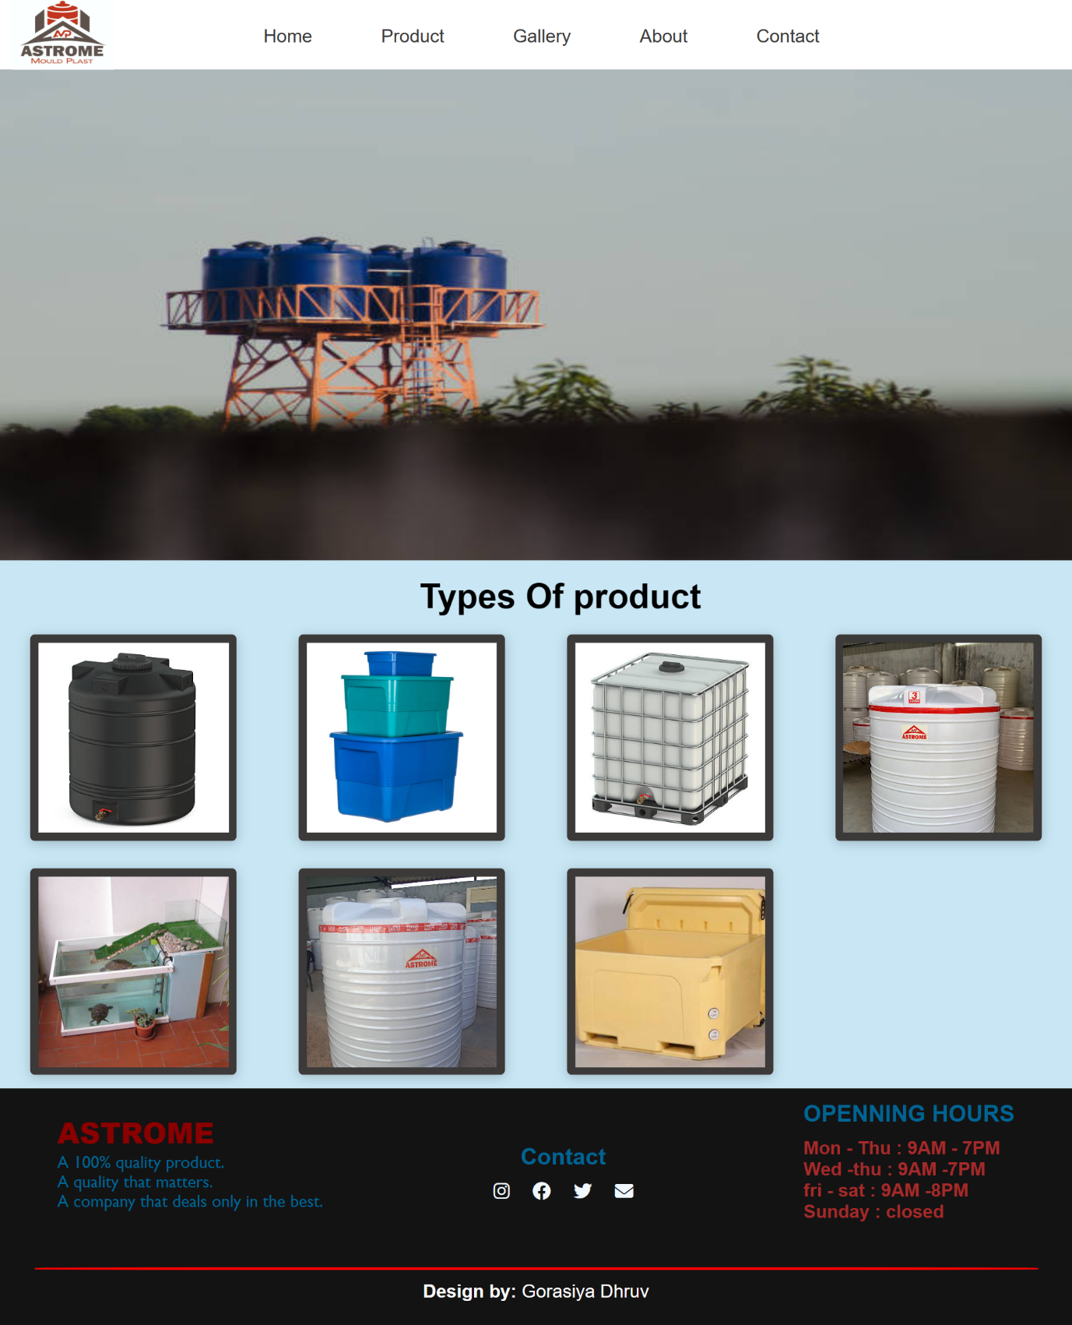

**Figure 7:**

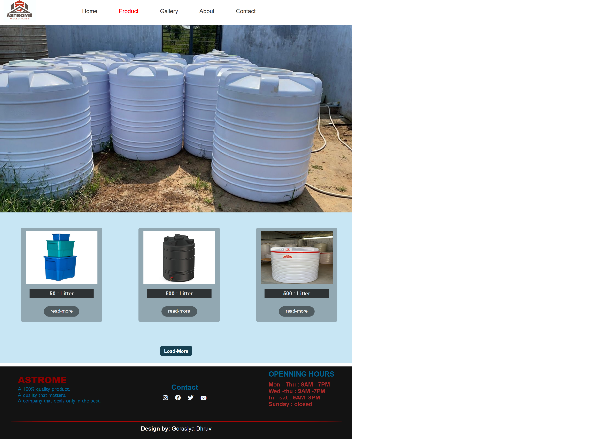

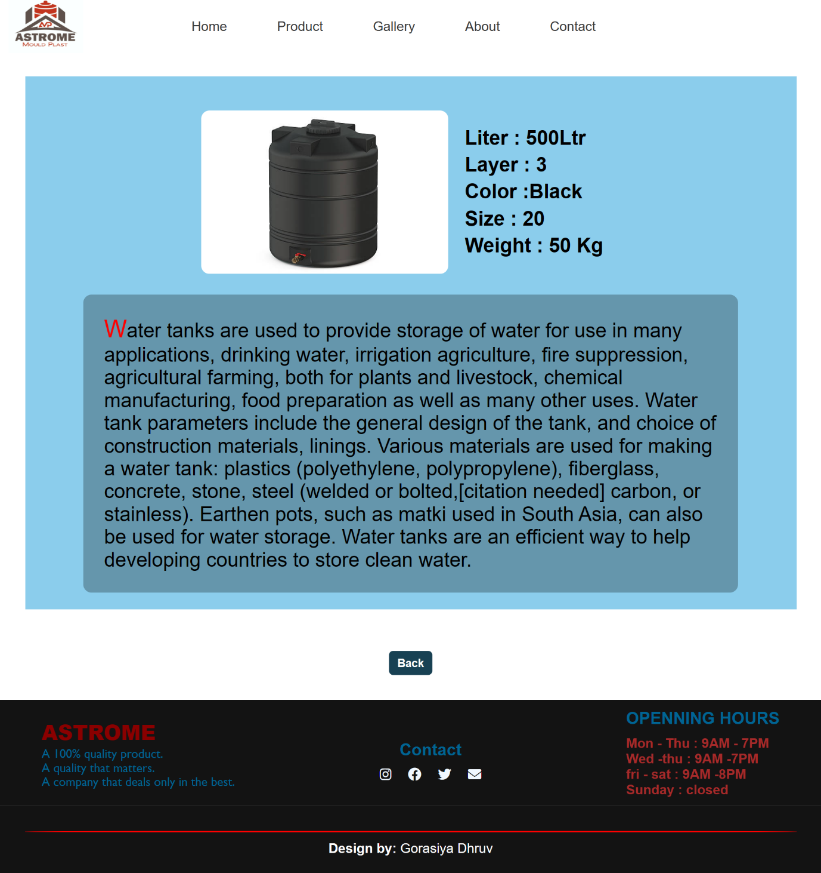

**Figure 8:**

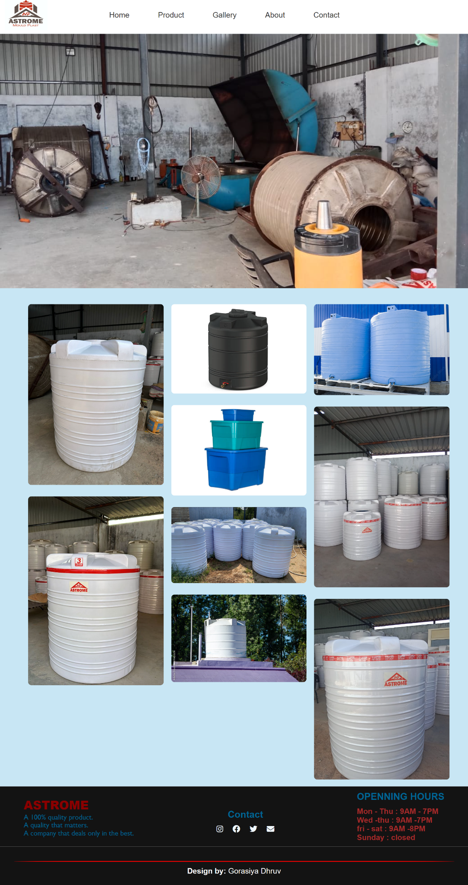

**Figure 9:**

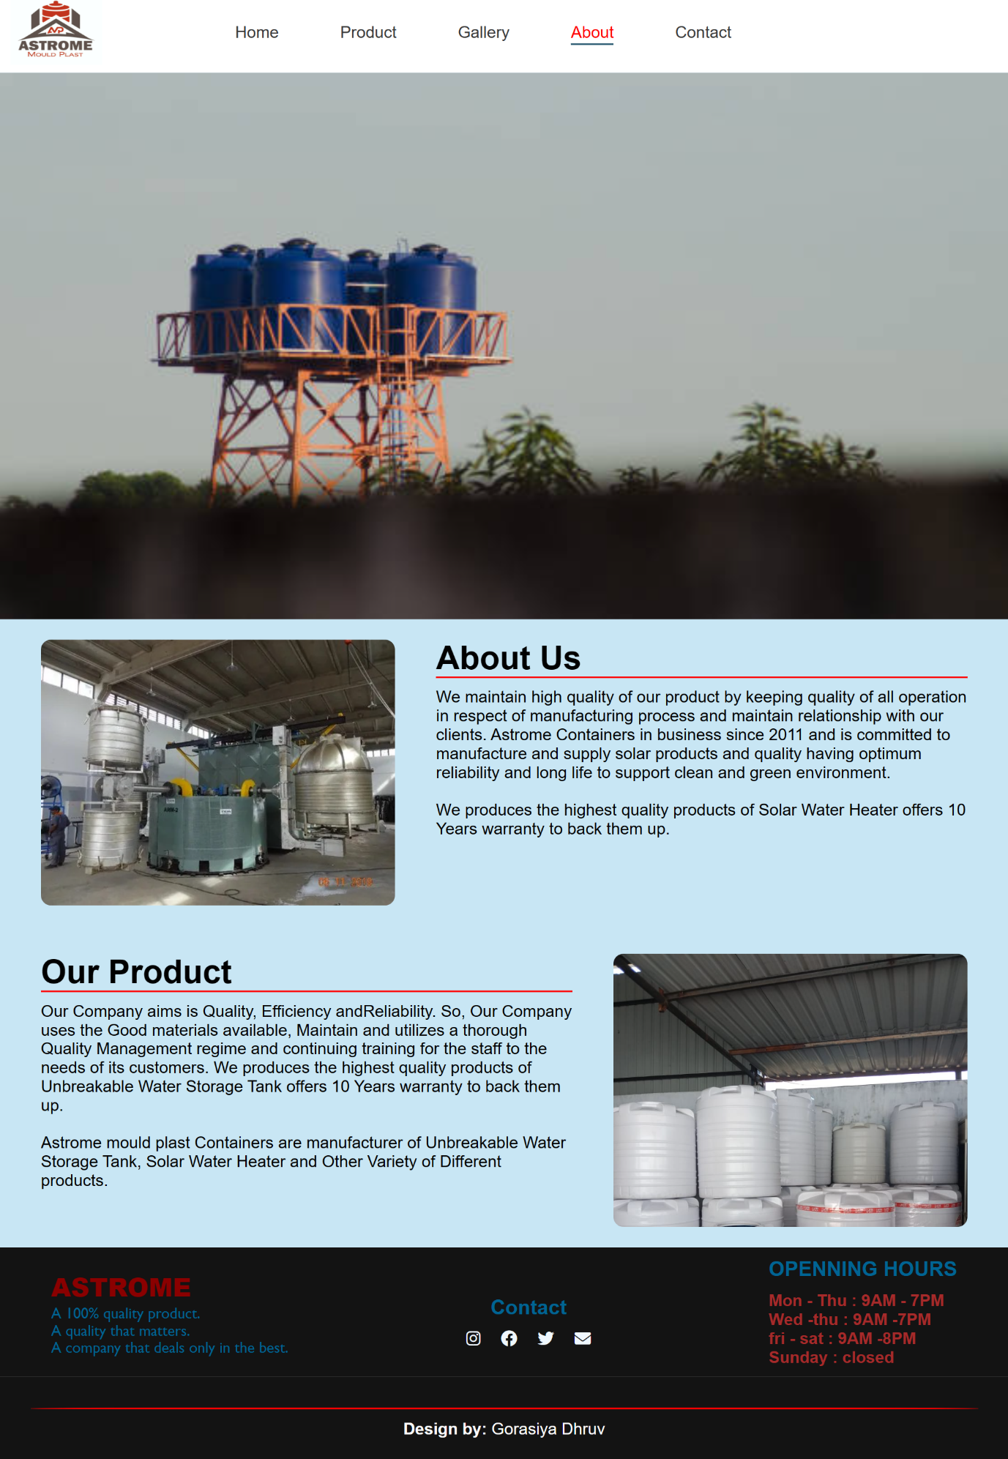

**Figure 10:**

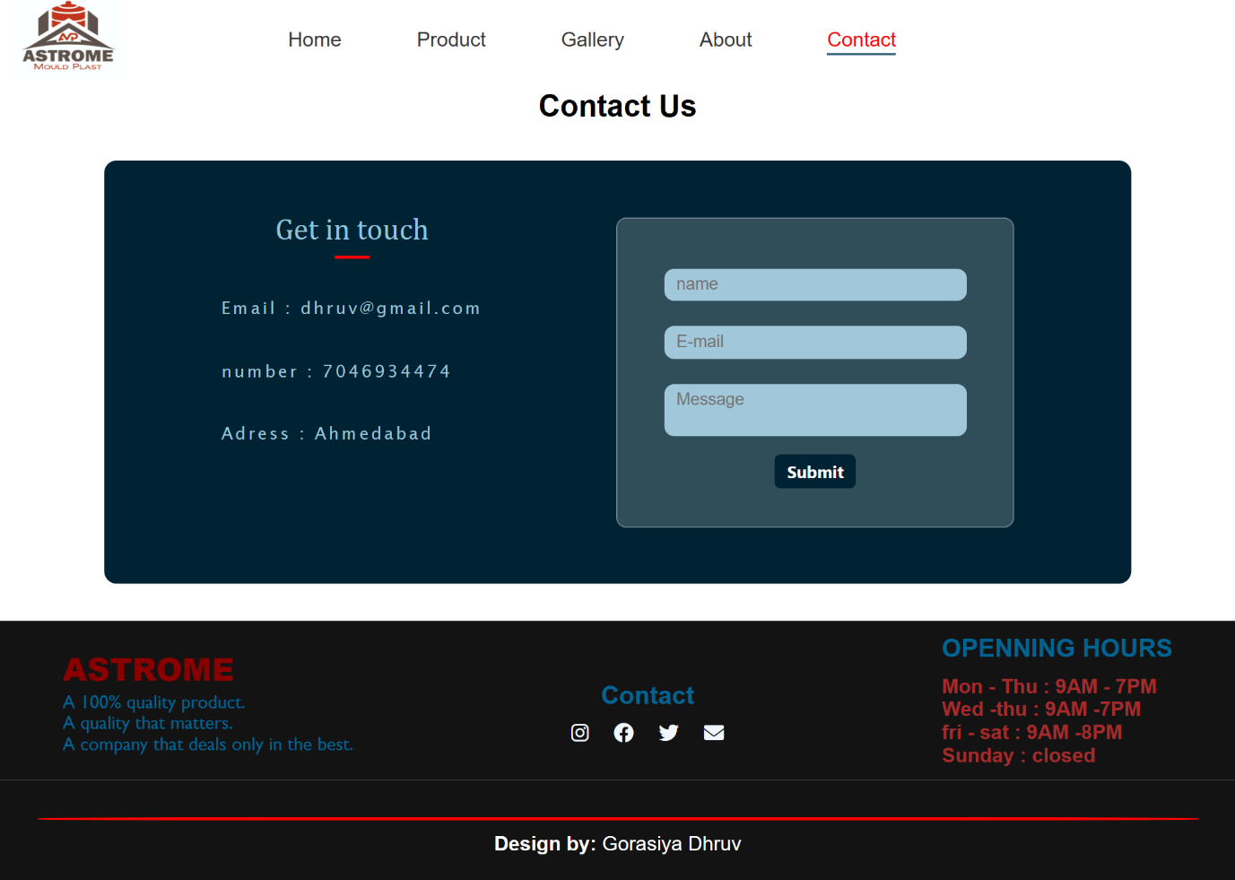

**7. Limitation of Project**

* This is project is platform dependent because it is run only on MS Windows operating system.

**8. Future Application of The Project**

* Astrome Mould Plast Is The Future.
* Plastic water storage tanks have a bright future ahead of them, with applications in the residential, industrial, agricultural, and municipal markets all holding promise.
* It is projected that the worldwide plastic water storage container industry would drop in 2020 as a result of the COVID-19-led global economic slowdown. In 2021, the market is predicted to recover and reach an anticipated $1.3 billion, with a CAGR of between 2% and 4% between 2020 and 2025.
* In this industry, building and water conservation are two of the most important factors driving growth.

**9.Bibliography:**

* There are some study materials which is used by me to develop my software system, which are as follows:

**Internet Sites:**

* [**https://www.npmjs.com/package/react-router-dom**](https://www.npmjs.com/package/react-router-dom)
* [**https://www.w3schools.com/**](https://www.w3schools.com/)

I am mostly use or preferred web site and you tube because that platforms are provide large amount of information what you want and also number of programmes related to query and project